Module 5 [Advanced Topics]:
Topic 1[Exception Handling]
Problem Statement: In the following input i is the index of array ax[]. The program prints ax[i]. Then write catch block if i is out of range of ax[]. Write three catch blocks to fullfill the purpose
- a catch block receives the value of i
- a catch block receives string “Out of Range Error”
- a default catch() if above two catch block doesn’t match
#include <iostream> using namespace std;

int main()
{
int i;
int ax[5]={10,20,60,40,30};
cout<<"enter index:"; cin>>i;
cout<<"ax["<<i<<"]="<<ax[i]<<endl;
}
Code:
#include <iostream>
using namespace std;

int main()
{
int i;
int ax[5]={10,20,60,40,30};
cout<<"Enter index(int):";
cin>>i;
try
{
if(i>4 || i<0)
{
throw(i);
}
if(cin.fail())
{
throw("notinteger");
}
cout<<"ax["<<i<<"]="<<ax[i]<<endl;
}
catch(int i)
{
cout << "Out of Range" << endl;
}
catch(const char *s)
{
cout << s << endl;
}
catch(...)
{
cout << "Exception is exception" << endl;
}
return 0;
}

Topic 2 [class Template]:
Problem Statement: In the following class data members x and y are integers and the method Sum() adds x and y. However, we need to perform the sum of int+int, int+double, douuble+int and double+double . To achieve it, change the definition of x,y,setData() and Sum() accordingly.

class A{ private:
int x; int y;
public:
void setData(int x,int y){ this->x=x;
this->y=y;
}
int Sum(){ int s; s=x+y; return s;
}
};
int main(){
//write required statements to call SetData() & Sum()
}

Code:

#include <iostream>
using namespace std;
template <class T1, class T2>
class A
{
T1 x;
T2 y;
public:
void setData(T1 x, T2 y) {
this-> x=x;
this ->y =y;
}
auto Sum()
{
return x + y;
}
};
int main()
{

A<int, int> obj1;
obj1.setData(10, 20);
cout << "Sum(int, int): " << obj1.Sum() << endl;
A<int, double> obj2;
obj2.setData(10, 5.5);
cout << "Sum(int, double): " << obj2.Sum() << endl;
A<double, int> obj3;
obj3.setData(3.5, 7);
cout << "Sum(double, int): " << obj3.Sum() << endl;
A<double, double> obj4;
obj4.setData(2.5, 3.5);
cout << "Sum(double, double): " << obj4.Sum() << endl;
return 0;
}

Topic 3 [STL:Array class]
Problem statement: Declare a STL array object ax with 6 elements and do the following:
- Assign 10,60,30,70,20 to ax using single statement
- Print third element of ax using at() function
- Print first element of ax using front() function
- Print last element of ax using back() function
- Fill the elements of ax using fill() function
- Test whether ax is empty or not using empty() function
- Print size of ax
- Print maximum size of ax using max_size() function
- Print address of first element of ax using begin() function
- Print address of last element of ax using end() function

#include <iostream> #include <bits/stdc++.h> using namespace std; int main(){
array<int,6>ax;
//write statements
}

Code:
#include <iostream>
#include <bits/stdc++.h>
using namespace std;

int main() {
array<int, 6> ax;

// i) assign using single statement
ax = {10, 60, 30, 70, 20, 90};

// ii) third element
cout << "Third element: " << ax.at(2) << endl;

// iii) first element
cout << "First element: " << ax.front() << endl;

// iv) last element
cout << "Last element: " << ax.back() << endl;

// v) fill
ax.fill(5);
cout << "After fill(): ";
for (int x : ax) cout << x << " ";
cout << endl;

// vi) empty
cout << "Is empty: " << (ax.empty() ? "Yes" : "No") << endl;

// vii) size
cout << "Size: " << ax.size() << endl;

// viii) max_size
cout << "Max size: " << ax.max_size() << endl;

// ix) address of first element
cout << "Address of first element: " << &(*ax.begin()) << endl;

// x) address of last element
cout << "Address of last element: " << &(*(ax.end() - 1)) << endl;

return 0;
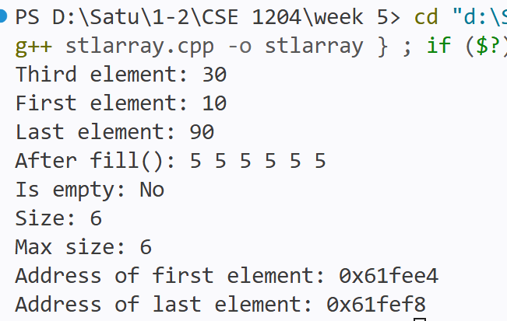
}

Topic 4[STL: pair class]
Problem statement: Define a pair class object px with int and string elements. Write statements to do the following
- Assign 10 to int and “Rajshahi” to px using make_pair() function
- Print int data member by first
- Print string data member by second
- Modify first data member to 20 using get<>() function
- Declare another pair bx and assign values to bx and swap it with ax
#include <iostream> #include <bits/stdc++.h> using namespace std; int main(){
pair<int,string>px;
//write statements
}

Code:
#include <iostream>
#include <bits/stdc++.h>
using namespace std;

int main() {
pair<int, string> px;

// i)
px = make_pair(10, "Rajshahi");

// ii)
cout << "First: " << px.first << endl;

// iii)
cout << "Second: " << px.second << endl;

// iv)
get<0>(px) = 20;
cout << "Modified First: " << px.first << endl;

// v)
pair<int, string> bx;
bx = make_pair(50, "Dhaka");

px.swap(bx);

cout << "After swap, px = (" << px.first << ", " << px.second << ")" << endl;
cout << "After swap, bx = (" << bx.first << ", " << bx.second << ")" << endl;

return 0;
}
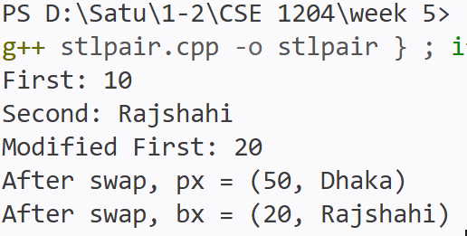

Topic 5 [STL: tuple class]
Problem statement: Define a tuple class object tx with int.string and double elements.
Write statements to do the following
- Assign <100,”Kamal”,3.5> to tx using make_tuple() function
- Print int data member by get() function

- Print string data member by get() function
- Print double data member by get() function
- Modify third data member to 3.7 using get<>() function
- Declare another tuple bx and assign values to bx and swap it with ax
#include <iostream> #include <bits/stdc++.h> using namespace std; int main(){
tuple<int,string,double>tx;
//write statements
}
Code:
#include <iostream>
#include <bits/stdc++.h>
using namespace std;

int main() {
tuple<int, string, double> tx;

// i)
tx = make_tuple(100, "Kamal", 3.5);

// ii)
cout << "Int: " << get<0>(tx) << endl;

// iii)
cout << "String: " << get<1>(tx) << endl;

// iv)
cout << "Double: " << get<2>(tx) << endl;

// v)
get<2>(tx) = 3.7;
cout << "Modified Double: " << get<2>(tx) << endl;

// vi)
tuple<int, string, double> bx;
bx = make_tuple(200, "Rahim", 4.2);

tx.swap(bx);

cout << "After swap, tx = ("
<< get<0>(tx) << ", "
<< get<1>(tx) << ", "
<< get<2>(tx) << ")" << endl;

cout << "After swap, bx = ("
<< get<0>(bx) << ", "
<< get<1>(bx) << ", "
<< get<2>(bx) << ")" << endl;

return 0;
}
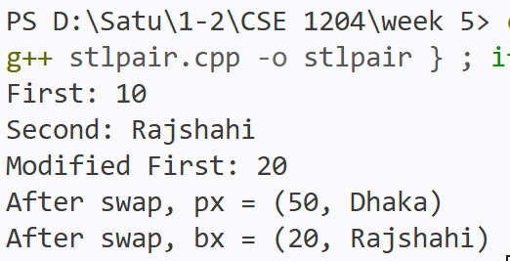

Topic 6 [STL: stack class]
Problem statement: Write a program to create and manipulate Stack using stack class and Perform the following operations using the specified method.
- use push() method to push data
- use pop() method to pop data
- use top() method to display top element
- use empty() method to check whether stack is empty or not
#include <iostream> #include <bits/stdc++.h> using namespace std; int main(){
stack<int>st;
//write statements
}

Code:
#include <iostream>
#include <bits/stdc++.h>
using namespace std;

int main() {
stack<int> st;

// push()
st.push(10);
st.push(20);
st.push(30);

// top()
cout << "Top element: " << st.top() << endl;

// pop()
st.pop();
cout << "After pop, top element: " << st.top() << endl;

// empty()
if (st.empty())
cout << "Stack is empty" << endl;
else
cout << "Stack is not empty" << endl;

return 0;
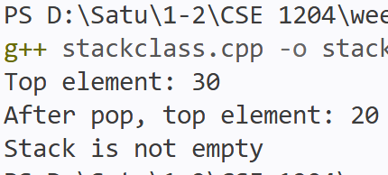
}

Topic 7 [STL: queue class]
Problem statement: Write a program to create and manipulate Queue using queue
class. Perform the following operations using the specified method.
- use push() method to push data
- use pop() method to pop data
- use front() method to display front element
- use back() method to display rear element
- use empty() method to check whether queue is empty or not
#include <iostream> #include <bits/stdc++.h> using namespace std; int main(){
queue<int>qu;

Code:
#include <iostream>
#include <bits/stdc++.h>
using namespace std;

int main() {
queue<int> qu;

// push()
qu.push(10);
qu.push(20);
qu.push(30);

// front()
cout << "Front element: " << qu.front() << endl;

// back()
cout << "Rear element: " << qu.back() << endl;

// pop()
qu.pop();
cout << "After pop, front element: " << qu.front() << endl;

// empty()
if (qu.empty())
cout << "Queue is empty" << endl;
else
cout << "Queue is not empty" << endl;

return 0;
}

//write statements
}

Topic 8 [STL: list class]
Problem statement: Write a program to create and manipulate linked list using list
class and its following methods to
- insert 8 integers using push_back() method
- insert two elements using push_front() method
- display all the elements of the list in forward direction with user-defined Display() method using begin() and end() methods and iterator
- display all the elements of the list in reverse direction with a user-defined DisplayRev() method using rbegin() and rend() method and iterator
- display front element using front() method
- display back element using back() method
- delete front element using pop_back() method
- delete front element using pop_front() method
- search an element x using find() method
- insert a new element x before an existing element y using insert() method
- insert a new element x after an existing element y using insert() method
- count a particular element x
- count a elements with condition using predicate function
- delete a particular element x with erase() method
- delete first 4 elements with erase() method
- delete a particular element x with remove() method
- delete a elements with condition using remove_if() method using predicate function
- assign elements from another list using assign() method
- assign elements from an array using assign() method
- sort the list using sort() method
- Delete consecutive similar elements using unique() method

Code: #include <iostream>
#include <iostream> #include <bits/stdc++.h> #include <iterator> #include <algorithm> using namespace std;

int main(){ list<int>li;
//write statements
}
#include <bits/stdc++.h>
#include <iterator>
#include <algorithm>
using namespace std;

bool isEven(int x) {
return x % 2 == 0;
}

void Display(list<int> li) {
list<int>::iterator it;
for (it = li.begin(); it != li.end(); it++) {
cout << *it << " ";
}
cout << endl;
}

void DisplayRev(list<int> li) {
list<int>::reverse_iterator it;
for (it = li.rbegin(); it != li.rend(); it++) {
cout << *it << " ";
}
cout << endl;
}

int main() {
list<int> li;

// i) insert 8 integers using push_back()
li.push_back(10);
li.push_back(20);
li.push_back(30);
li.push_back(40);
li.push_back(50);
li.push_back(60);
li.push_back(70);
li.push_back(80);

// ii) insert two using push_front()
li.push_front(5);
li.push_front(1);

cout << "Forward: ";
Display(li);

// iv) reverse display
cout << "Reverse: ";
DisplayRev(li);

// v) front()
cout << "Front element: " << li.front() << endl;

// vi) back()
cout << "Back element: " << li.back() << endl;

// vii) delete back using pop_back()
li.pop_back();
cout << "After pop_back: ";
Display(li);

// viii) delete front using pop_front()
li.pop_front();
cout << "After pop_front: ";
Display(li);

// ix) search an element x using find()
int x = 30;
auto it = find(li.begin(), li.end(), x);
if (it != li.end())
cout << x << " found" << endl;
else
cout << x << " not found" << endl;

// x) insert a new element x before existing y
int newVal1 = 25, y1 = 30;
auto it1 = find(li.begin(), li.end(), y1);
if (it1 != li.end()) {
li.insert(it1, newVal1);
}
cout << "After insert before 30: ";
Display(li);

// xi) insert a new element x after existing y
int newVal2 = 35, y2 = 30;
auto it2 = find(li.begin(), li.end(), y2);
if (it2 != li.end()) {
++it2;
li.insert(it2, newVal2);
}
cout << "After insert after 30: ";
Display(li);

// xii) count a particular element x
cout << "Count of 30: " << count(li.begin(), li.end(), 30) << endl;

// xiii) count elements with condition
cout << "Count of even elements: " << count_if(li.begin(), li.end(), isEven) << endl;

// xiv) delete a particular element x with erase()
auto it3 = find(li.begin(), li.end(), 25);
if (it3 != li.end()) {
li.erase(it3);
}
cout << "After erase(25): ";
Display(li);

// xv) delete first 4 elements with erase()
auto start = li.begin();
auto finish = li.begin();
advance(finish, 4);
li.erase(start, finish);
cout << "After deleting first 4 elements: ";
Display(li);

// xvi) delete a particular element x with remove()
li.remove(60);
cout << "After remove(60): ";
Display(li);

// xvii) delete elements with condition using remove_if()
li.remove_if(isEven);
cout << "After remove_if(isEven): ";
Display(li);

// xviii) assign elements from another list
list<int> li2;
li2.push_back(100);
li2.push_back(200);
li2.push_back(300);

li.assign(li2.begin(), li2.end());
cout << "After assign from another list: ";
Display(li);

// xix) assign elements from an array
int arr[] = {7, 8, 9, 10};
li.assign(arr, arr + 4);
cout << "After assign from array: ";
Display(li);

// xx) sort the list
li.push_back(2);
li.push_back(15);
li.sort();
cout << "After sort: ";
Display(li);

// xxi) delete consecutive similar elements using unique()
li.push_back(15);
li.push_back(15);
li.push_back(20);
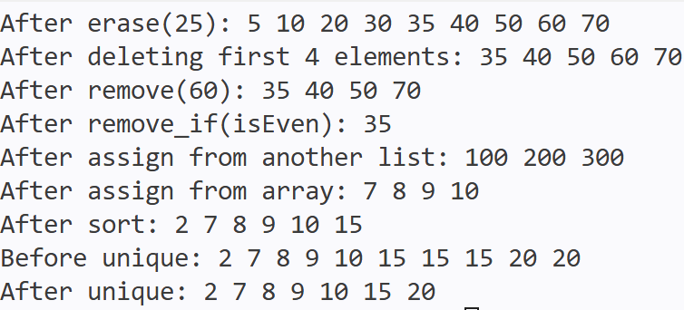
li.push_back(20);
li.sort();
cout << "Before unique: ";
Display(li);

li.unique();
cout << "After unique: ";
Display(li);

return 0;
}

